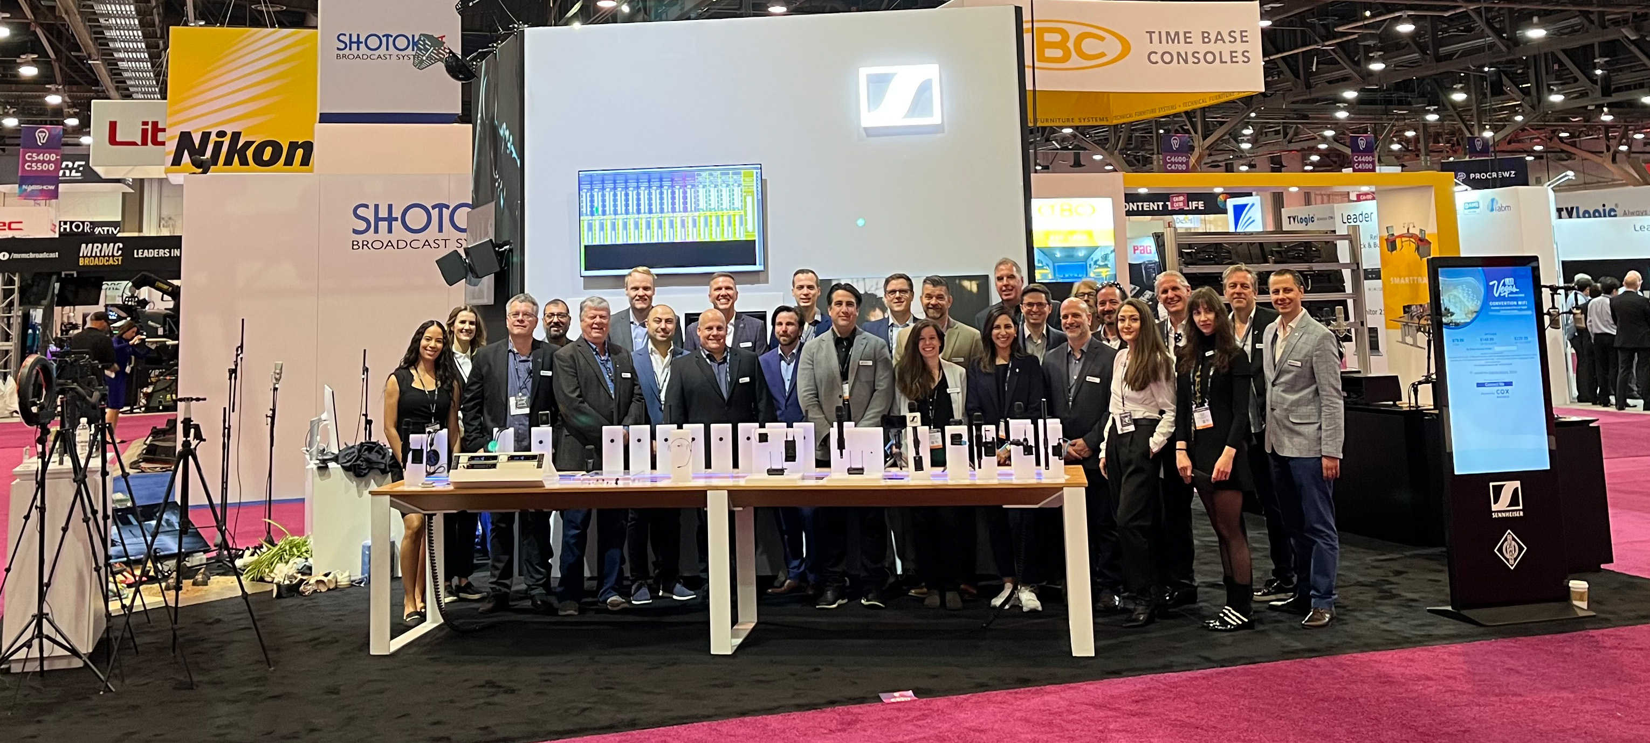

Welcome to the Sennheiser Group’s Experience Booth at NAB 2024
Sennheiser, Neumann, Dear Reality and Merging Technologies showcase end-to-end audio solutions for broadcasting, studio and live audio on an interactive booth

Las Vegas, April 2024 – The Sennheiser Group invites NAB visitors to embark on a remarkable sonic journey at booth 4732 in Central Hall. The Experience Booth will be a fully integrated space where all microphones and headsets on show can be tried interactively. This is the perfect opportunity to get enveloped in rich sound – from Neumann studio microphone classics and Sennheiser’s MKH 8000 RF condenser microphone series, to Merging Technologies’ Anubis and Hapi, as well as the group’s complete professional headphone offering. Here’s more information on the highlights at booth C4732:

Sennheiser MKH 8030 RF condenser microphone and new accessories for the MKH 8000 series
The long-awaited MKH 8030 figure-of-eight RF condenser microphone unlocks M-S, double M-S, and Blumlein stereo recording options for the recording professional. The sound signature of the MKH 8030 has been carefully engineered to blend in harmoniously with the sound of the other MKH 8000 series microphones. The MKH 8030 is also a great choice wherever the highest attenuation of neighbouring sound sources is required – be it a PA system whose sound needs to be eliminated or an adjacent instrument that must not be picked up. Their special RF condenser principle and the symmetrical capsule design endows the MKH 8000 series microphones with a combination of advantages that can only be found in this series: Remarkable sensitivity paired with durability in adverse climatic conditions, wide frequency response, low self-noise, and a natural, coherent sound image with no off-axis coloration.

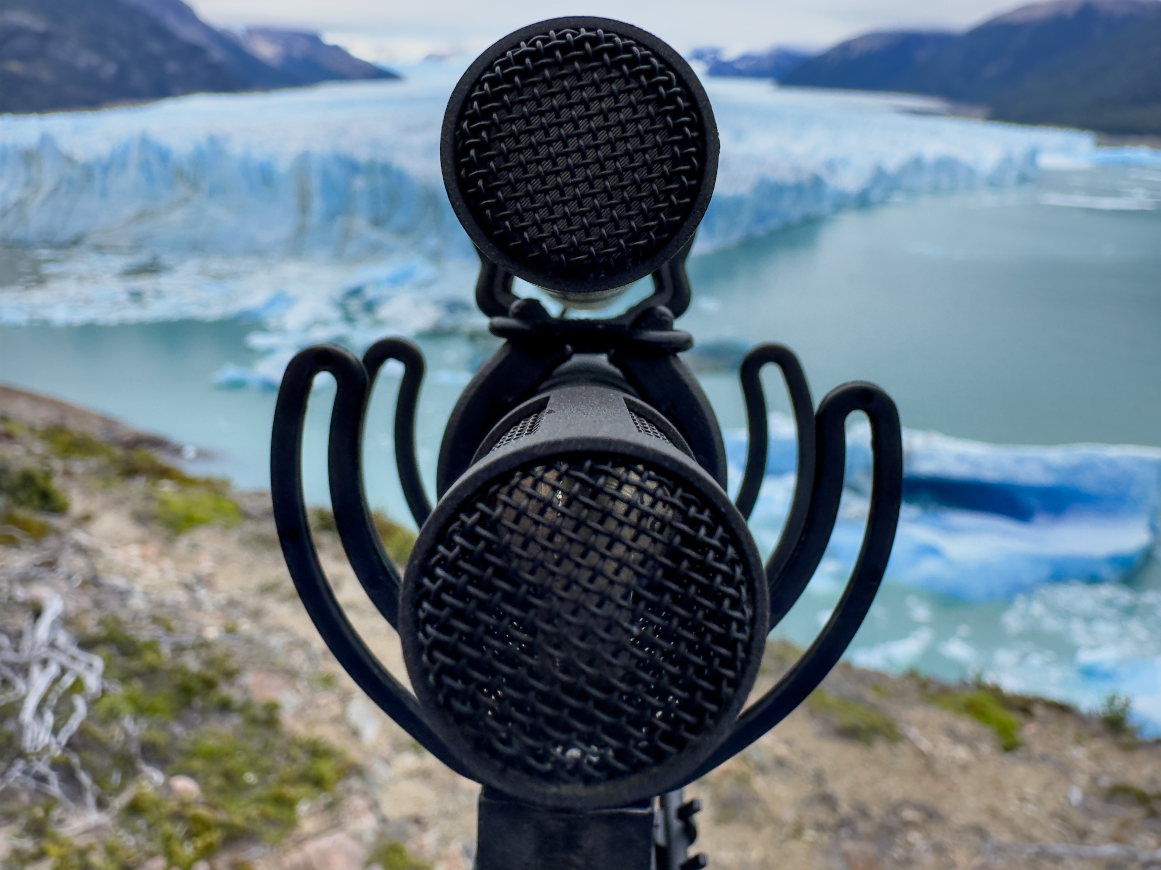
The Sennheiser MKH 8000 series is at home in the most diverse recording situations, from the orchestra pit to field recording in extreme climates (photo credit for the fjord shot: Thomas Rex Beverly). The right-hand picture shows Simon Charles from Sound in Dubai, making an MS stereo recording using the new MKH 8030. Simon has more than two decades of expertise in sound production, encompassing a diverse range of projects such as short films, features, TV series, documentaries, commercials, and corporate productions (Photo credit: Zeus Mehri)

In addition to the full MKH range, Sennheiser also showcases new accessories: To accommodate the left/right orientation of the MKH 8030, the MZE extension tubes of the series have been fitted with a rotatable head. The MZGE 8000 tube connector has been improved, now featuring a more robust design. New in the accessory portfolio is the MZH 8042 gooseneck, which brings the exceptional audio quality of a connected MKH microphone, for example the MKH 8040, to the lectern.

The MKH 8030 and the new accessories will be available from May 2024. Find out more about the MKH 8030 here.

Streamlined and improved broadcast headset portfolio
At NAB, Sennheiser showcases its streamlined and improved headset portfolio for broadcast applications, which will become available from July 1, 2024. To make the selection of the right headset easier and clearer, improved headset models can now be combined with a choice of five separately available cables.
The lightweight, open HMD 46 (dynamic mic) and HME 46 (electret mic) headsets are ideal for intercom use, both featuring improved speech intelligibility.
The closed, supra-aural HMD 26 (dynamic mic) and HME 26 (electret mic) headsets are ideal for outside broadcast applications and now boast switchable ActiveGard (off/95 dB/110 dB). Sennheiser’s ActiveGard protects the wearer’s hearing from sudden sound bursts without interrupting the audio signal – an added safety feature that differs from traditional acoustic shock clipping circuitry. Both models are also available as a single-sided version, the HMD 26 S and HME 26 S.
The closed, circumaural top-end series HMD 27 and HME 27 ensure highest monitoring accuracy in loud environments and outstanding comfort for the wearer. These models now also come with switchable ActiveGard (off/95 dB/110 dB). The HMDC 27 is additionally fitted with NoiseGard active noise reduction.
Last but not least, the closed, circumaural HMD 300 ActiveGard headset for backstage communications has been fitted with a new dynamic boom mic and arm, delivering improved performance. It is also available as a single-sided model (HMD 300 S), and as the cost-effective HMD 300 X3K1, which has the XLR-3/1/4” jack plug cable included.
Except for the latter, all headsets need to be combined with a choice of XLR-3 / 1/4” jack, XLR-4F and XLR-5 M cables or unterminated cables (single and twin). All HME headsets are now designed to work with phantom power only.

Sennheiser’s portfolio of broadcast headsets has been streamlined and improved, pictured are (from left to right): the open HME 46; the closed, supra-aural HMD 26; the closed, circumaural HMDC 27 with NoiseGard active noise reduction; and the closed, circumaural HMD 300 X3K1 with included XLR-3/1/4” jack plug cable.

The Neumann MT 48 becomes an immersive audio interface
Neumann’s reference-class audio interface MT 48 will be shown with both the Music Mission for content creation and the brand new Monitor Mission. The latter turns the device into a freely configurable monitor controller and audio interface for stereo, surround and immersive formats. The MT 48 will also be used for demoing Neumann’s KH line of studio monitors as well as the NDH 20 closed-back and NDH 30 open-back headphones.

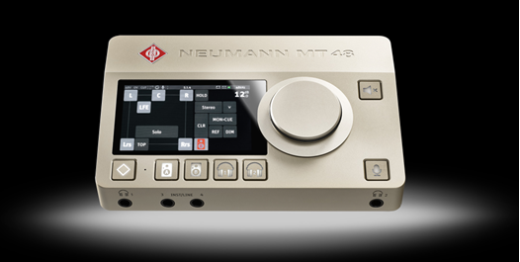

Additionally, Neumann will show its well-established line of broadcast microphones, the BCM 104 and BCM 705, which were specially developed to meet the demands of radio, podcast and live streaming. Also on display will be a selection of Neumann’s studio classics such as the U 87 Ai and TLM 103, as well as the KMR 81 and KMR 82 shotgun microphones.

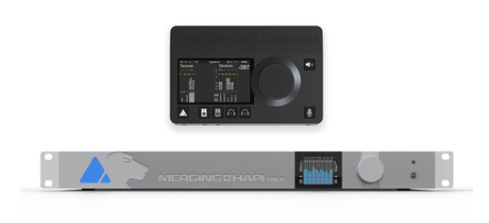

Merging Technologies at the Sennheiser Group booth
Meet the Merging team in Las Vegas! With the Merging sales division now fully integrated into the Sennheiser Group, the Swiss manufacturer of the finest digital audio recording systems showcases its innovative range of audio technology and AoIP solutions. Visitors can expect the full line-up of Anubis and Hapi hardware, as well as the Ovation media server and Pyramix software. Additionally, Merging is hosting several demos across the show, headed up by Dennis Gaines, one of the company’s longest standing representatives.

Dear Reality’s latest spatial audio software solutions
Dear Reality, pioneer in spatial audio technologies, will demo dearVR PRO 2, the successor to its industry-leading dearVR PRO spatial audio plugin. dearVR PRO 2 empowers audio engineers and musicians to produce immersive audio with ease. Featuring innovative functions such as stereo input control, OSC head-tracker support, and extended Pro Tools compatibility, dearVR PRO 2 sets a new benchmark for crafting spatially rich and emotionally resonant 3D audio soundscapes. NAB attendees will have the opportunity to experience the captivating new features of dearVR PRO 2 live, including its lifelike early reflections, 46 virtual acoustic presets, and extensive support for multichannel loudspeaker formats.

Dear Reality will show the successor of its dearVR PRO spatializer. dearVR PRO 2 adds a stereo input, gives users access to new immersive Pro Tools formats, features new high-pass and low-pass filters for early reflections and late reverb, and supports OSC head trackers | 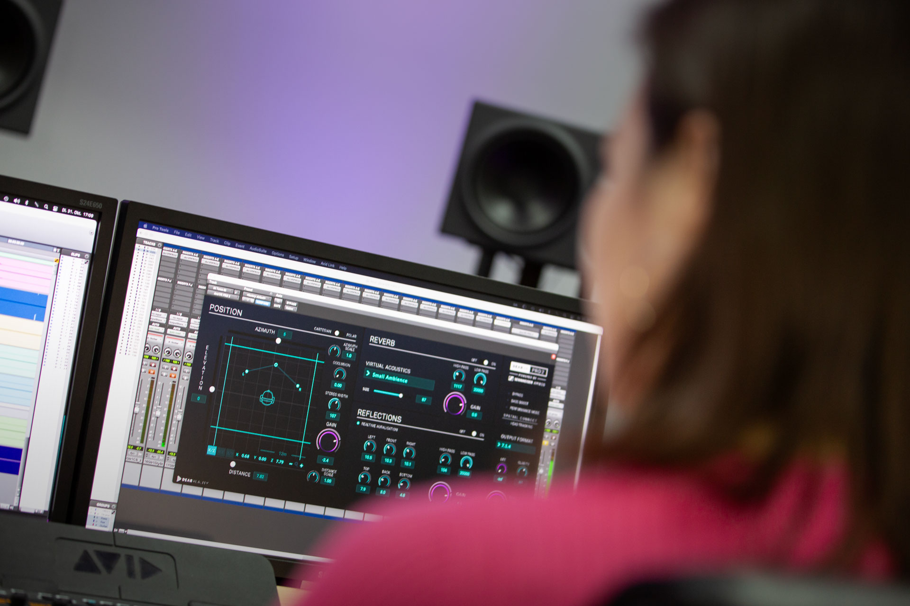

Also on show is the dearVR MONITOR plugin, which simulates a multichannel loudspeaker set-up in a high-quality mixing studio on a pair of stereo headphones. The plugin enables users to reliably mix in any environment by combining the analytical advantages of headphone monitoring with the perception of mixing in a perfectly adjusted room.

And there is something for stereo mixing, too: Besides dearVR MIX-SE, a stereo mixing solution specifically designed for Sennheiser headphones, Dear Reality also demos EXOVERB, a stereo reverb plugin. This plugin offers exceptionally realistic sound quality and an innovative, intuitive control in creating the perfect blend of reverb, early reflections, and dry signal. Both plugins are designed to take the art of stereo mixing to new immersive heights.

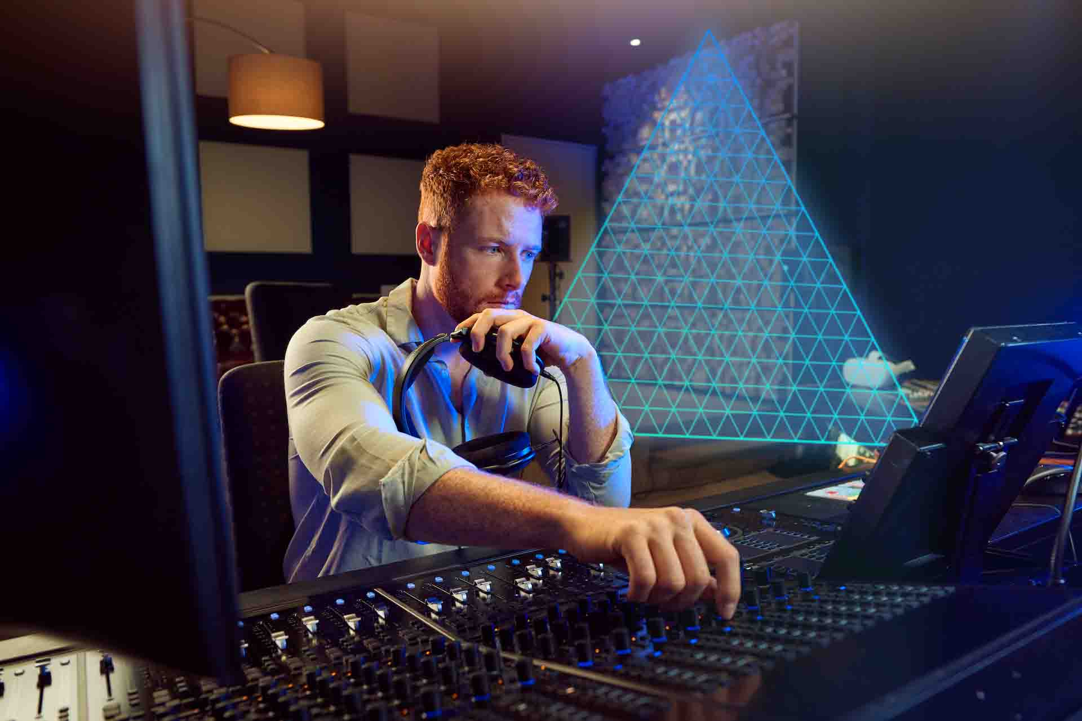 | The EXOVERB stereo reverb plugin features an innovative “triangle control” to create the perfect blend of reverb, early reflections, and dry signal

Exclusive WMAS sessions in demo room N204LMR
In February, the Federal Communication Commission (FCC) approved a change in its regulation, now permitting operation of Wireless Multichannel Audio Systems (WMAS) in the United States. Sennheiser is delighted to offer private, in-depth information sessions on this new technology that will revolutionize multichannel wireless microphone and IEM set-ups. The sessions will take place at 11 a.m. and 2 p.m. on April 14 – 16, and at 11 a.m. on April 17 in the North Hall Meeting Room N204LMR. Please note that you may have to sign an NDA to attend these exclusive sessions.

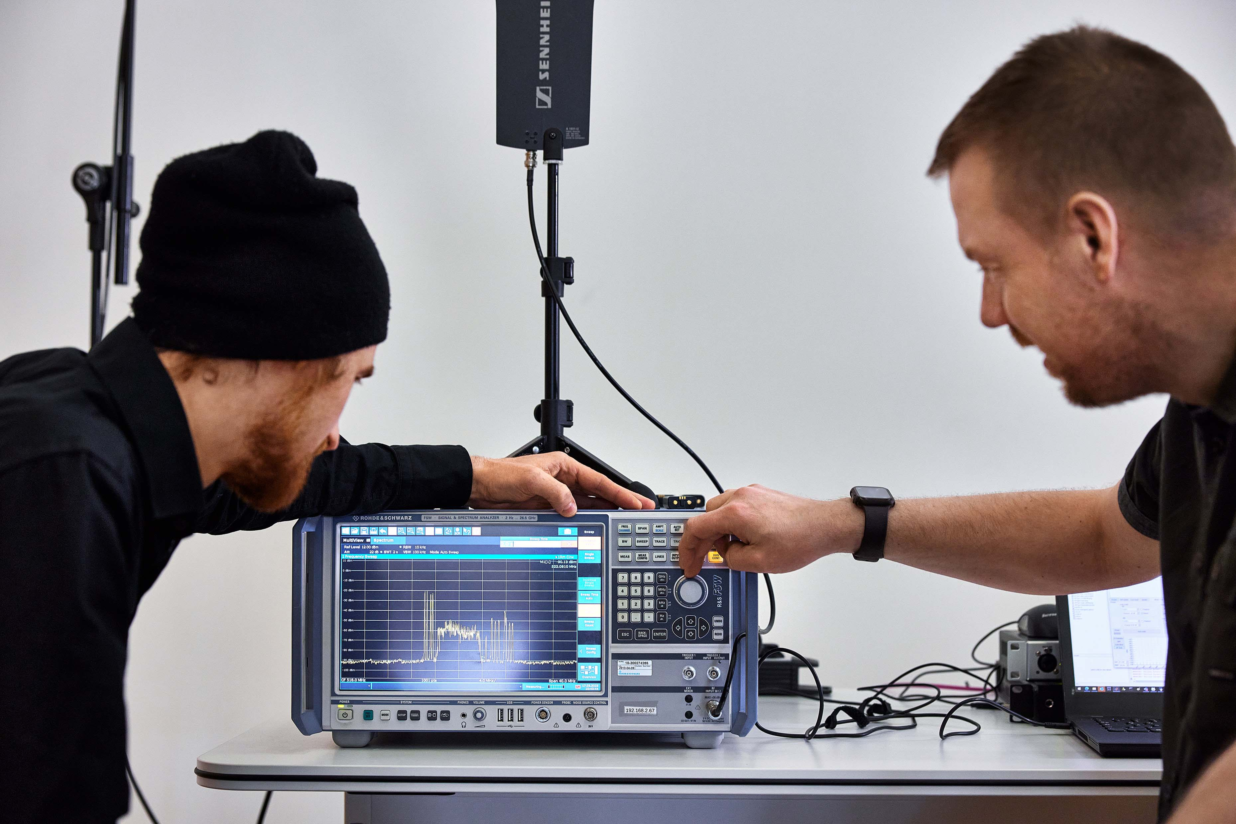 | At NAB, Sennheiser will offer private information sessions on WMAS in meeting room N204LMR. Daily at 11 a.m. and 2 p.m., and at 11 a.m. on the last show day

Global promotion for selected filmmaking and videography gear
The start of NAB 2024 also marks the start of a month-long global promotion for selected wireless and wired camera microphones – a great opportunity to upgrade your audio:

MODEL | Standard price  (EUR: MSRP,  USD: MAP) | Promotional price  (EUR: MSRP,  USD: MAP)
MKE 400 Camera Microphone
MKE 400 | EUR/USD 199 | EUR/USD 169
MKE 400 Mobile Kit | EUR/USD 229 | EUR/USD 199
EW-DP UHF Wireless Audio Sets
EW-DP ENG SET | EUR/USD 899 | EUR/USD 799
EW-DP ME 2 SET | EUR/USD 699 | EUR/USD 599
EW-DP ME 4 SET | EUR/USD 699 | EUR/USD 599
EW-DP 835 SET | EUR/USD 699 | EUR/USD 599

Promotional pricing commences Monday, April 15th and will run through Sunday, May 19th, 2024. Standard pricing will be back in effect on Monday, May 20th, 2024.

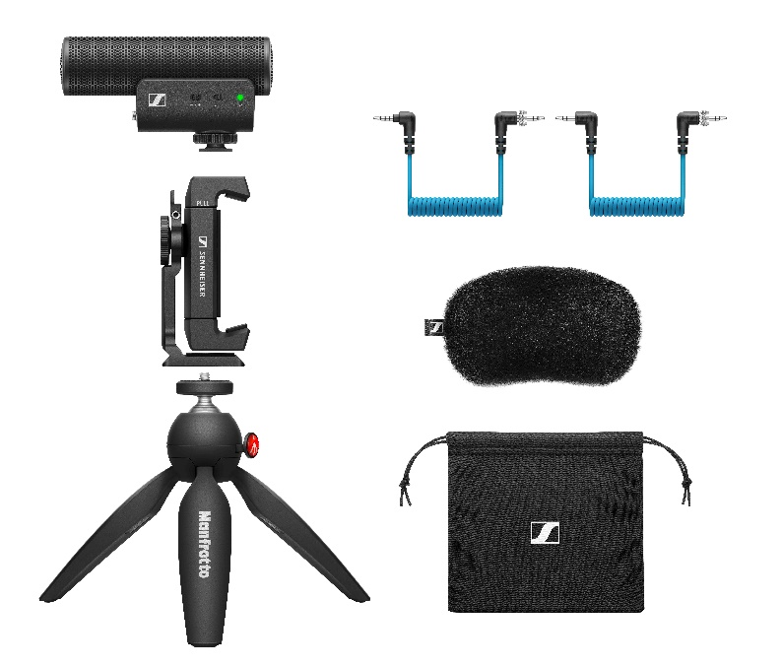 | 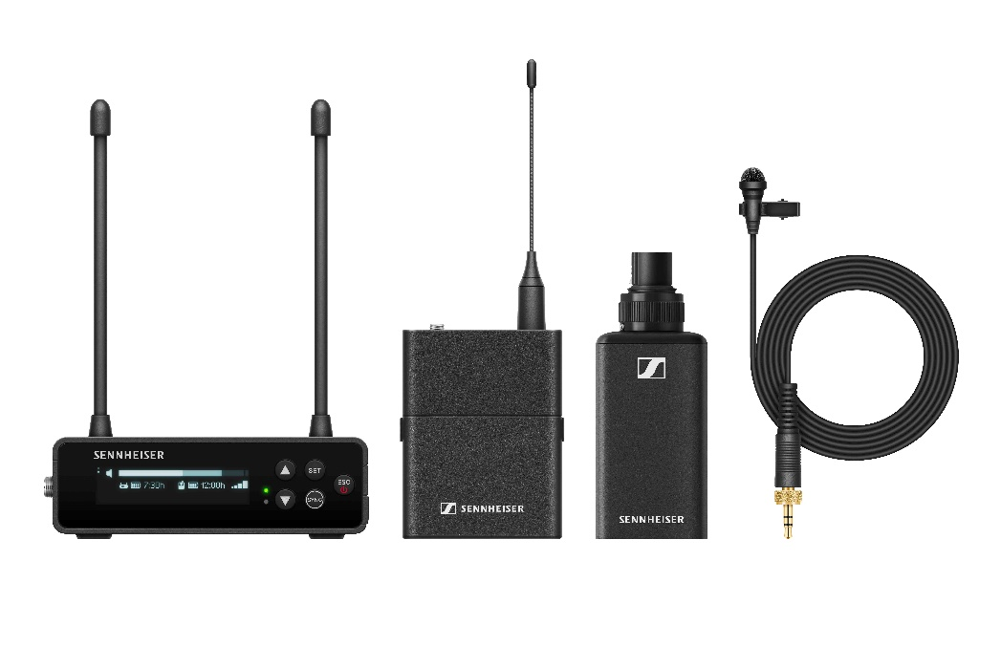
Global NAB promotion for the MKE 400, MKE 400 Mobile Kit (pictured, left) and all EW-DP UHF wireless microphone systems (pictured is the EW-DP ENG SET, right)

Loan service for content creation at NAB
As a special service for creators at NAB, the Sennheiser team has a few of its highlight products on loan. Whether some of your own gear is broken or lost in transit, or you would like to use the opportunity to try something new, you’re welcome to choose between the following loan items on a first come, first served basis:
Wireless systems: EW-DP ENG Sets, consisting of a single-channel camera receiver with all mounting accessories, a bodypack transmitter with ME 2 omni-directional clip-on mic and an SKP plug-on transmitter with on-board 32-bit float recording. Make sure you also borrow one of the shotgun or handheld mics if you would like to use the SKP – or use it with the lav mic.
Shotgun mics: MKE 600 condenser shotgun mics, MKH 8060 RF condenser shotgun mics
Reporter microphones: MD 42 omni-directional dynamic mics
Handheld microphones: evolution e 835 (cardioid), e 845 (super-cardioid) and e 935 (cardioid) dynamic microphones
Monitoring headphones: HD 25 closed, supra-aural monitoring headphones
Clip-on/lavalier microphones: MKE 1, MKE 2, and ME 2 omni-directional clip-on mics

As a special extra, some of the brand-new HD 490 PRO open studio headphones are on loan, too.

Visit the Sennheiser Group at NAB, Central Hall C4732 and in demo room N204LMR.

(Ends)

The images accompanying this media release and additional product photos can be downloaded here.

About the Sennheiser Group

Building the future of audio and creating unique sound experiences for our customers - this is the aspiration that unites the employees of the Sennheiser Group worldwide. The independent family-owned company Sennheiser was founded in 1945. Today, it is managed in the third generation by Dr. Andreas Sennheiser and Daniel Sennheiser, and is one of the leading manufacturers in the field of professional audio technology.
sennheiser.com | neumann.com | dear-reality.com | merging.com

